Ben
Weekly Relays User Guide
TOPICS LEGEND
 |  | WEEKLY RELAYS |  | July 20, 2023
  YOUR DEPARTMENT NEWS |  |  |   UTMB NEWS
Class of 2027  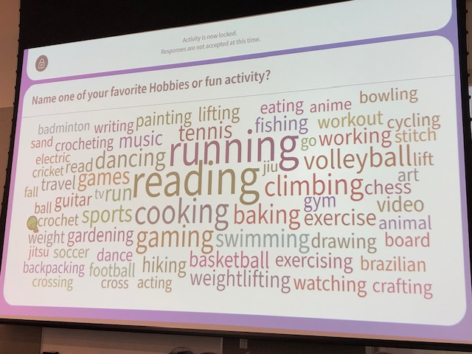  The incoming JSSOM class was asked at orientation to name a hobby or fun activity. The above word cloud gives us a little sense of who they are personally.    Congratulations to Dr. Misha Syed  on her recent appointment to the  ACGME Board of Appeals!  Graduation and Celebration of  the Egyptian Research Scholar  and Clinical Observership Program  Ten Scholars from Egypt have been at UTMB for the past six months working with various mentors in clinical, foundational science, and administrative positions. A notable number of UTMB faculty had the opportunity to enjoy working with this outstanding group of scholars.  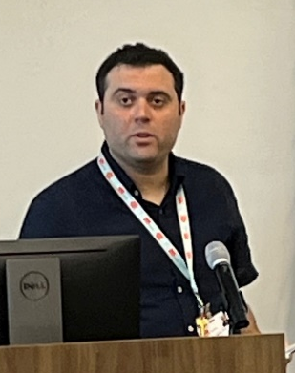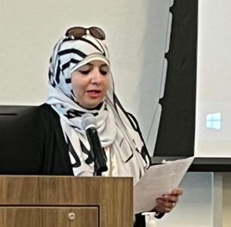  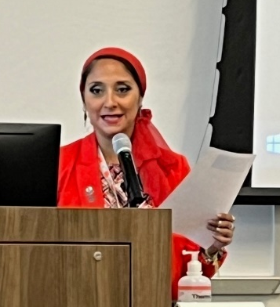  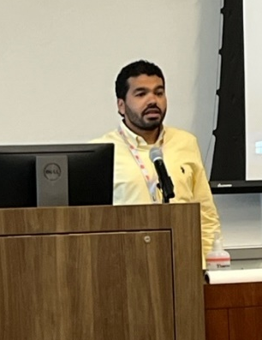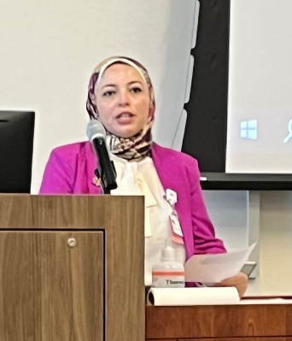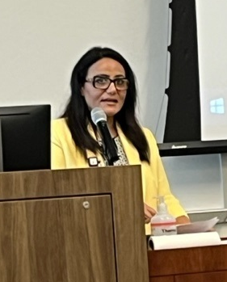  A celebration of their achievements and lessons learned was held on Friday, June 30, 2023. Each scholar will return to Egypt with plans to implement new programming in their institutions.  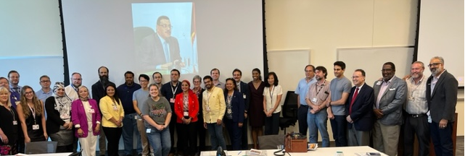  The program was initiated under an affiliation agreement between UTMB and the Egyptian Cultural and Educational Bureau at the Egyptian Embassy in Washington DC.  Dr. Hani Serag and Dr. Hanaa Sallam organized and oversaw the implementation of this wonderful program at UTMB. |  |  | UTMB Community invited to welcome reception for President Jochen Reiser  Please join University of Texas System Chancellor James B. Milliken at a reception to welcome UTMB’s President Jochen Reiser on Aug. 16 from 5 to 6:30 p.m. on the second floor of the Health Education Center (HEC) on the Galveston Campus.  IMPORTANT! Weekly Relay Notes transitioning to be fully integrated into iUTMB (intranet) home page  Beginning Aug. 7, the Weekly Relay Notes will be fully integrated into a redesigned iUTMB, the university’s internal home page for faculty, staff and students. The Weekly Relay Notes will no longer be published after the Aug. 3 edition but the archive of past Notes will remain available online. Transitioning Weekly Relay Notes to iUTMB will improve UTMB’s methods for disseminating important news, alerts and announcements by providing each employee with immediate, direct access to information that is important to them, while still encouraging and supporting leaders in their efforts to expand on the institution’s news as it applies to their individual teams and departments​.  What comes next?  - Beginning next week, users can access a link on the current iUTMB home page to preview the new iUTMB, which will feature a new “Inside UTMB” section to include articles that were previously published in the Weekly Relay Notes. During the preview period, feedback will be solicited from users of iUTMB and Weekly Relay Notes.  - On Aug. 7, the new iUTMB page will officially launch as the default internal home page.  To learn more about the transition or to ask questions, visit https://intranet.utmb.edu/weeklyrelay.  Monthly Financial Results—As of June 30, 2023  For the month of June, UTMB’s Adjusted Margin loss was $6.9 million, which was $6.8 million unfavorable to planned results. Year-to-date, UTMB’s Adjusted Margin loss was $10.2 million, which was $18.7 million favorable to planned results. Month of June results are due, in part, to unfavorable net patient care revenue related to a decline in volumes and caring for lower acuity patients, combined with unfavorable results related to salaries and benefits. UTMB, like all academic health systems, continues to face higher-than-anticipated costs due to inflation and a competitive labor market. Your continued diligent efforts are needed to manage expenses and maximize revenue and associated collections as UTMB grows operations and revenues for long-term success.
OPICS  LEGEND |         PATIENT CARE EDUCATION & RESEARCH INSTITUTIONAL SUPPORT CMC
AROUND UTMB (Use the legend above to quickly find items of interest to your team)
UTMB on the 2023 Galveston County Daily News 40 Under 40 list  Congratulations to seven UTMB colleagues who were recognized in The Galveston County Daily News 40 Under 40 list for 2023.  This year’s honorees were:  - Megan Cazares, Associate Director of Accreditation  - Rawan Harirah, Director, Visiting Education  - C. Tyler Morrison, Exercise Physiologist  - Christopher Richter, Medical Student  - Maria San Andrés, Assistant Professor, Pediatrics  - Tracy Tang, Medical Student  - Vivian Tat, Pre-doctoral Research Fellow  To read more, visit https://utmb.us/92f.  Apple iCloud accounts using UTMB email address: Employees to receive special instructions via email from Apple  If you log into your Apple iCloud account using your UTMB email address, you will soon receive an email from Apple that outlines steps you must take to separate that account from your UTMB email address. This change is being made in preparation for a UTMB Information Technology Services security enhancement that will be deployed in the coming weeks across the institution. The process of separating your UTMB email address from your Apple iCloud account, however, will be outlined in the Apple email you receive and will be controlled by Apple.  IN CASE YOU MISSED IT  July 13: Clear Lake Connections podcast  UTMB’s Leen Nahouli, AuD, audiologist with the Center for Audiology and Speech Pathology, was recently featured on the Clear Lake Area Chamber of Commerce Clear Lake Connections podcast. In the episode, Leen Nahouli discusses the field of Audiology, different types of hearing loss, prevention and treatments to help people with hearing loss. To hear the full discussion, visit https://utmb.us/92g.  July 19: Houston Moms Blog – Navigating the big transitions at school  From the first day of kindergarten all the way through departing for college, one’s academic journey is filled with lots of big “firsts” that sometimes bring about big changes to daily habits, practices and routines. To help parents, guardians and children successfully navigate the many unknowns and emotions that often come along with these various transitions, UTMB psychologists with the Department of Psychiatry and Behavioral Sciences Dr. Barbara Calvert, associate professor, and Dr. Kimberly Gushanas, assistant professor, offer guidance, support and tips during a recent interview with our partners at Houston Moms. To watch the full discussion, visit the Houston Moms Facebook page.  REMINDERS (cont.)  Aug. 9-11: 2023 Employee Service Day celebrations  UTMB will celebrate the commitment and contributions of our employees Aug. 9–11. Activities will be held at each of the campus locations and online to honor 1,738 faculty and staff for achieving significant service milestones and 699 GEM card recipients for going the extra mile in their daily activities. Visit https://www.utmb.edu/hr/employees/service-day for a schedule of activities and a complete list of honorees.  SAVE THE DATE  July 26: Health Care Unmasked on “Back-to-School Primer for Parents”  Airing at noon on July 21, the next episode of Health Care Unmasked will feature UTMB pediatricians Dr. Lauren Raimer-Goodman, Dr. Monica Thint and Dr. Maria Nguyen. The group will join host TJ Aulds to discuss a “Back-to-School Primer for Parents.” The episode will be available on the i45Now Facebook page.  PATIENT CARE  Latest issue of Health System Heartbeat now online  Jeepers Creepers! Which UTMB doc feeds his inner adrenaline fanatic by taking his Jeep on treacherous treks? And which ADC staffer is Chris Brown’s biggest fan? Uncover these interesting tidbits and more in the July issue of the Health System Heartbeat newsletter. Find it at https://www.utmb.edu/heartbeat. And don’t forget to share your ideas for August. Email your favorite photos, recipes, suggestions for stories, etc. to mmbattis@utmb.edu.  EDUCATION & RESEARCH  Dr. Beth Ulrich to receive the Sigma Theta Tau International Honor Society of Nursing’s Nell J. Watts Lifetime Achievement in Nursing Award  Congratulations to Dr. Beth Ulrich, Professor in the School of Nursing’s Department of Graduate Studies. She has been selected by Sigma Theta Tau International Honor Society of Nursing to receive the Nell J. Watts Lifetime Achievement in Nursing Award. This is one of the most prestigious honors bestowed by the Board of Directors and given to a Sigma member who has demonstrated exemplary achievements in nursing throughout their lifetime. The awards will be conferred during Sigma’s 47th Biennial Convention in San Antonio, in November. |  |  | CONSTRUCTION NOTICE  July 22-23: Closure of all lanes of I-45 in League City and Webster planned for this weekend  On Saturday, July 22, TxDOT will close all lanes on I-45 in both directions between FM 518 and the NASA Bypass.  The closure is scheduled through noon Sunday, July 23, and will enable TXDOT work crews to install overhead freeway signage.  With all northbound and southbound lanes closed, traffic will be rerouted onto the feeder roads.  The southbound I-45 entrance ramp will be closed from Bay Area Boulevard during the work.  Traffic will exit southbound I-45 using the exit ramp to FM 528 and continue on the feeder, reentering southbound I-45 using the entrance ramp from NASA Road 1.  The northbound I-45 entrance ramp from FM 518 will also be closed; traffic will re-enter northbound I-45 using the entrance ramp from FM 528.  As a reminder, check online sources for current conditions and alternate routes.  - Houston Transtar Traffic Map*  - TxDOT Construction Schedule and Closures (filter on "IH-45 in Galveston County")  - Google Maps Live Traffic  - Waze Live Map  * If you are reviewing Transtar freeway cams, check the date stamp to ensure the image is live. Many cameras have been offline during construction.  REMINDERS  July 25: UTMB to host Employee Memorial Service  Family, friends and colleagues are invited to the UTMB Employee Memorial Service on July 25 from noon to 1 p.m. at William C. Levin Hall Auditorium on the Galveston Campus. This service provides an opportunity to honor friends, family members and fellow UTMB employees who have passed away the previous year. The memorial service will also be livestreamed for those who cannot attend in person. To view names of the employees being remembered or to access the virtual service on July 25, visit https://www.utmb.edu/celebrate/memorial-service.  Benefits Annual Enrollment ends July 31  Annual enrollment for the 2023–2024 benefits plan year ends July 31. You may view or update your current coverage by logging in to the My UT Benefits online system. To access the system, you will need to identify UTMB as your institution and enter your UTMB username and password. For more annual enrollment information, including a recording of the annual enrollment virtual fair, employee guidebooks, and benefits cost worksheets, please see https://www.utmb.edu/hr/employees/compensation-and-benefits/annual-enrollment.
DID YOU KNOW?
During a ceremony in Orlando, Florida, last month, the UTMB Police Department received two awards from the International Association of Campus Law Enforcement Administrators (IACLEA). The International Medal of Valor was awarded to UTMB Sgt. Kristopher McGill; officers Travis Gonzales, Arron Hernandez and Shantardrick Hester; and telecommunicators Alana Dickey and Daniel Markovich, for their emergency response in August 2022. In addition, the IACLEA honored Chief Kenith Adcox, who received the Administrative Excellence Award in recognition of the department’s programs and innovative training opportunities relating to the prevention of workplace violence. To learn more, visit https://utmb.us/92m.

